**Think Bridge**

**Parth Patil**

Prerequisite: SQL server 2012 or greater, Visual studio, Visual studio code, node installed, .net frameworks installed

*1.How to setup project on local machine.*

-> The first thing is to clone the repo from that github from the following link :-

[**https://github.com/Parth0231/ThinkBridge.git**](https://github.com/Parth0231/ThinkBridge.git)

*2. Create DB*

-> open the DB folder from the cloned repo and open the sql script in SSMS and execute it

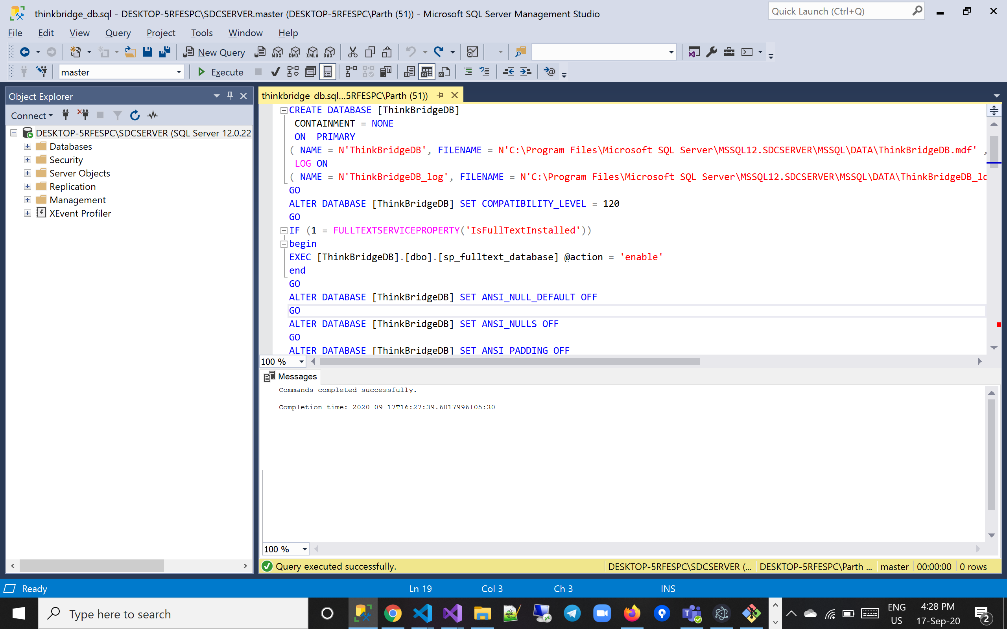

After the execution you will receive a message ‘Commands completed successfully.

’

*3.Open the frontend folder in VS code*

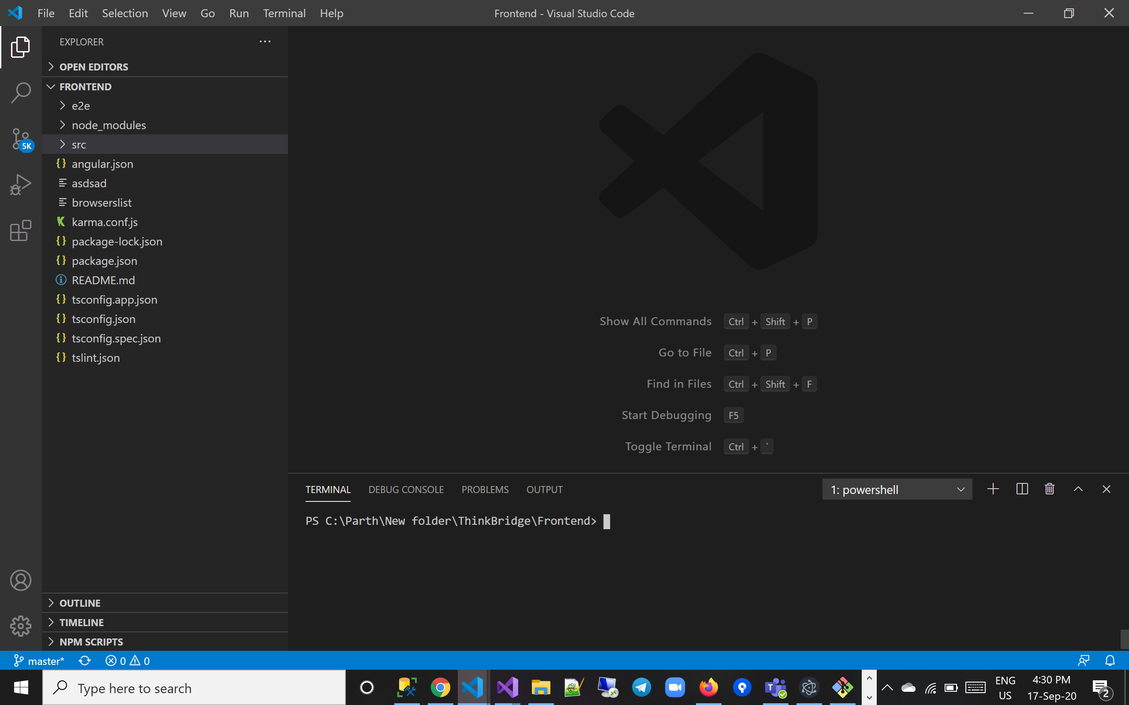

* Open new terminal once the frontend project folder is opened in VS code
* Enter command **npm install**

4. Open the Backend folder in VS

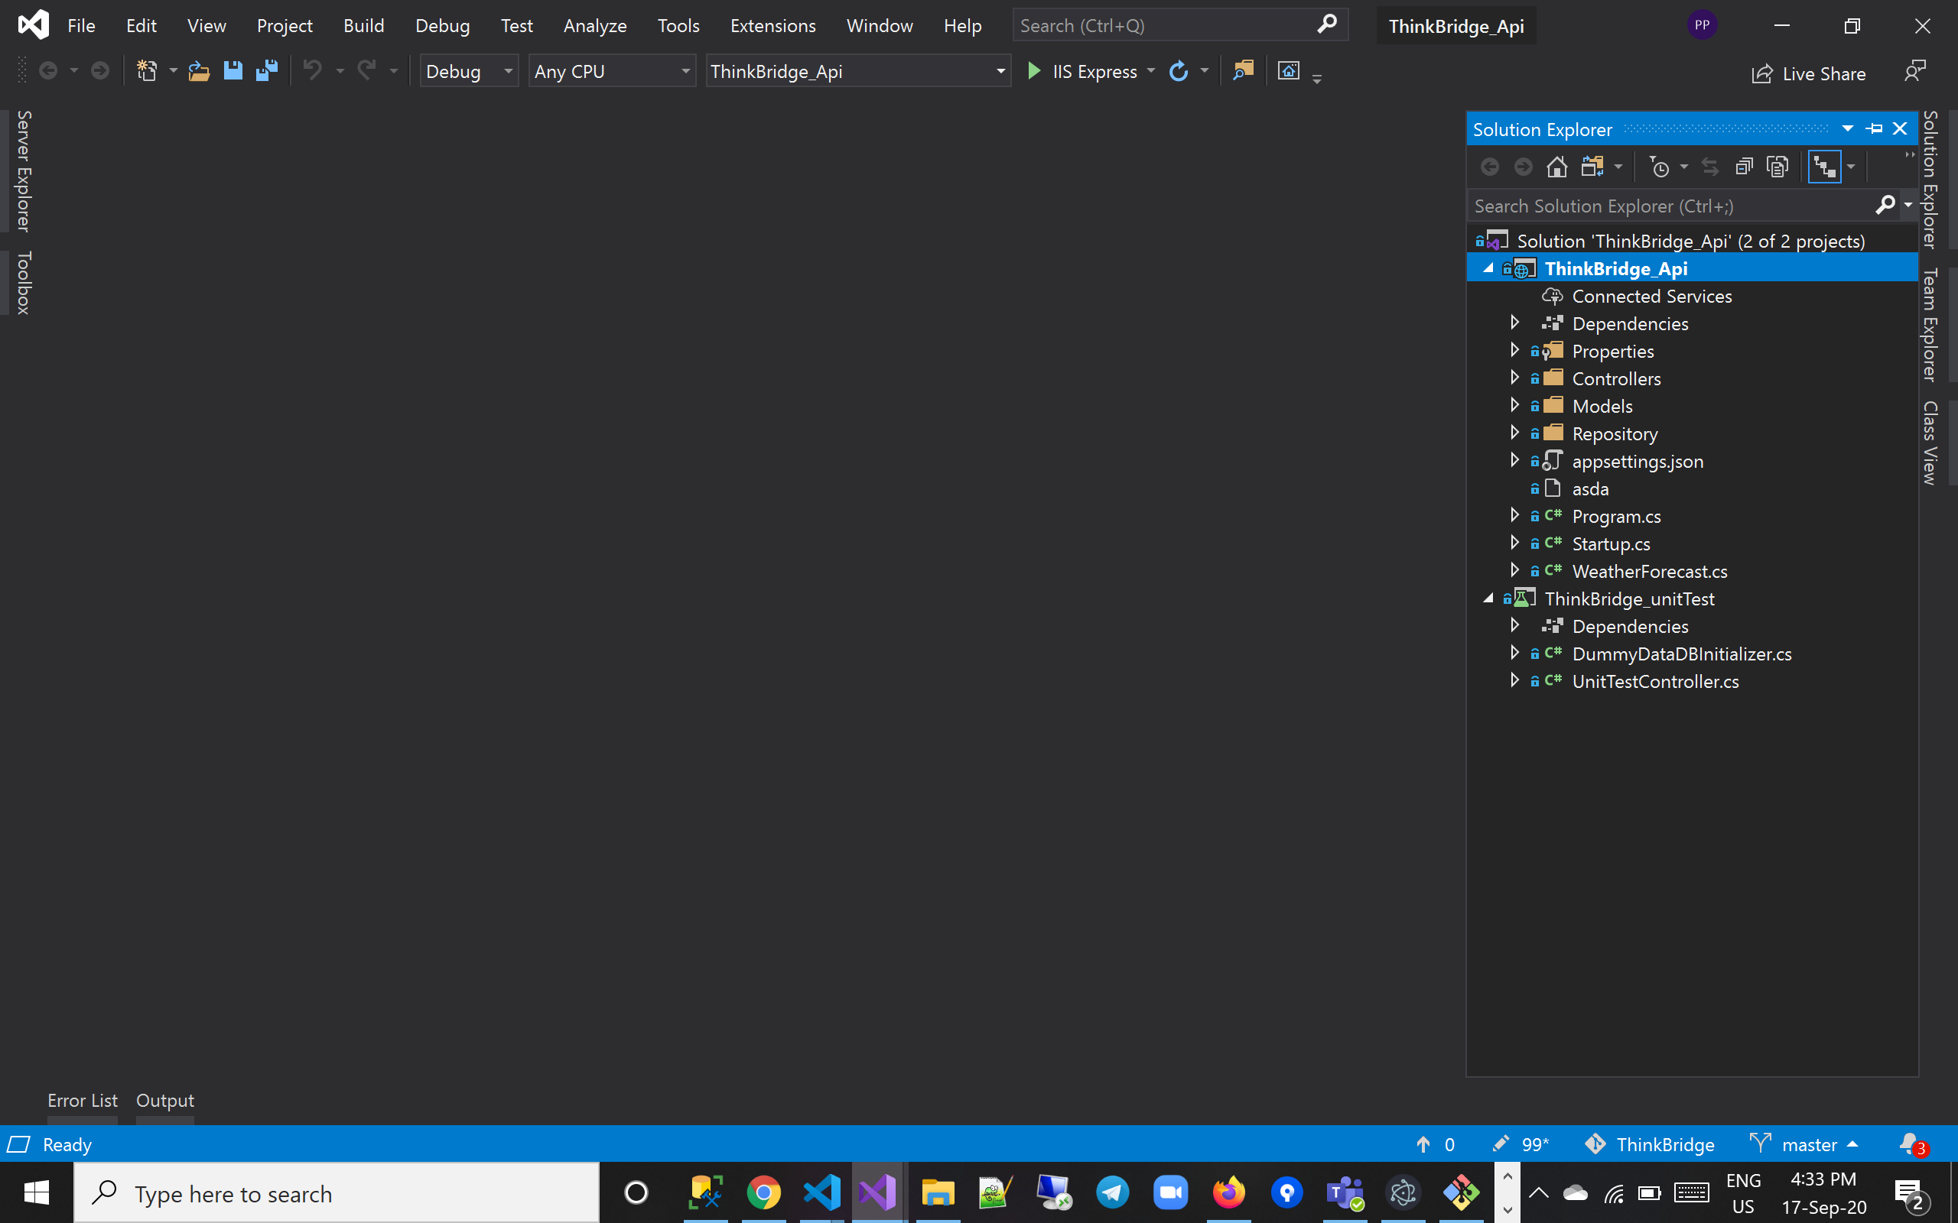

*5.DB connection string*

-> in appsetting.json replace the server name to your local sql serve name you can find it in SSMS

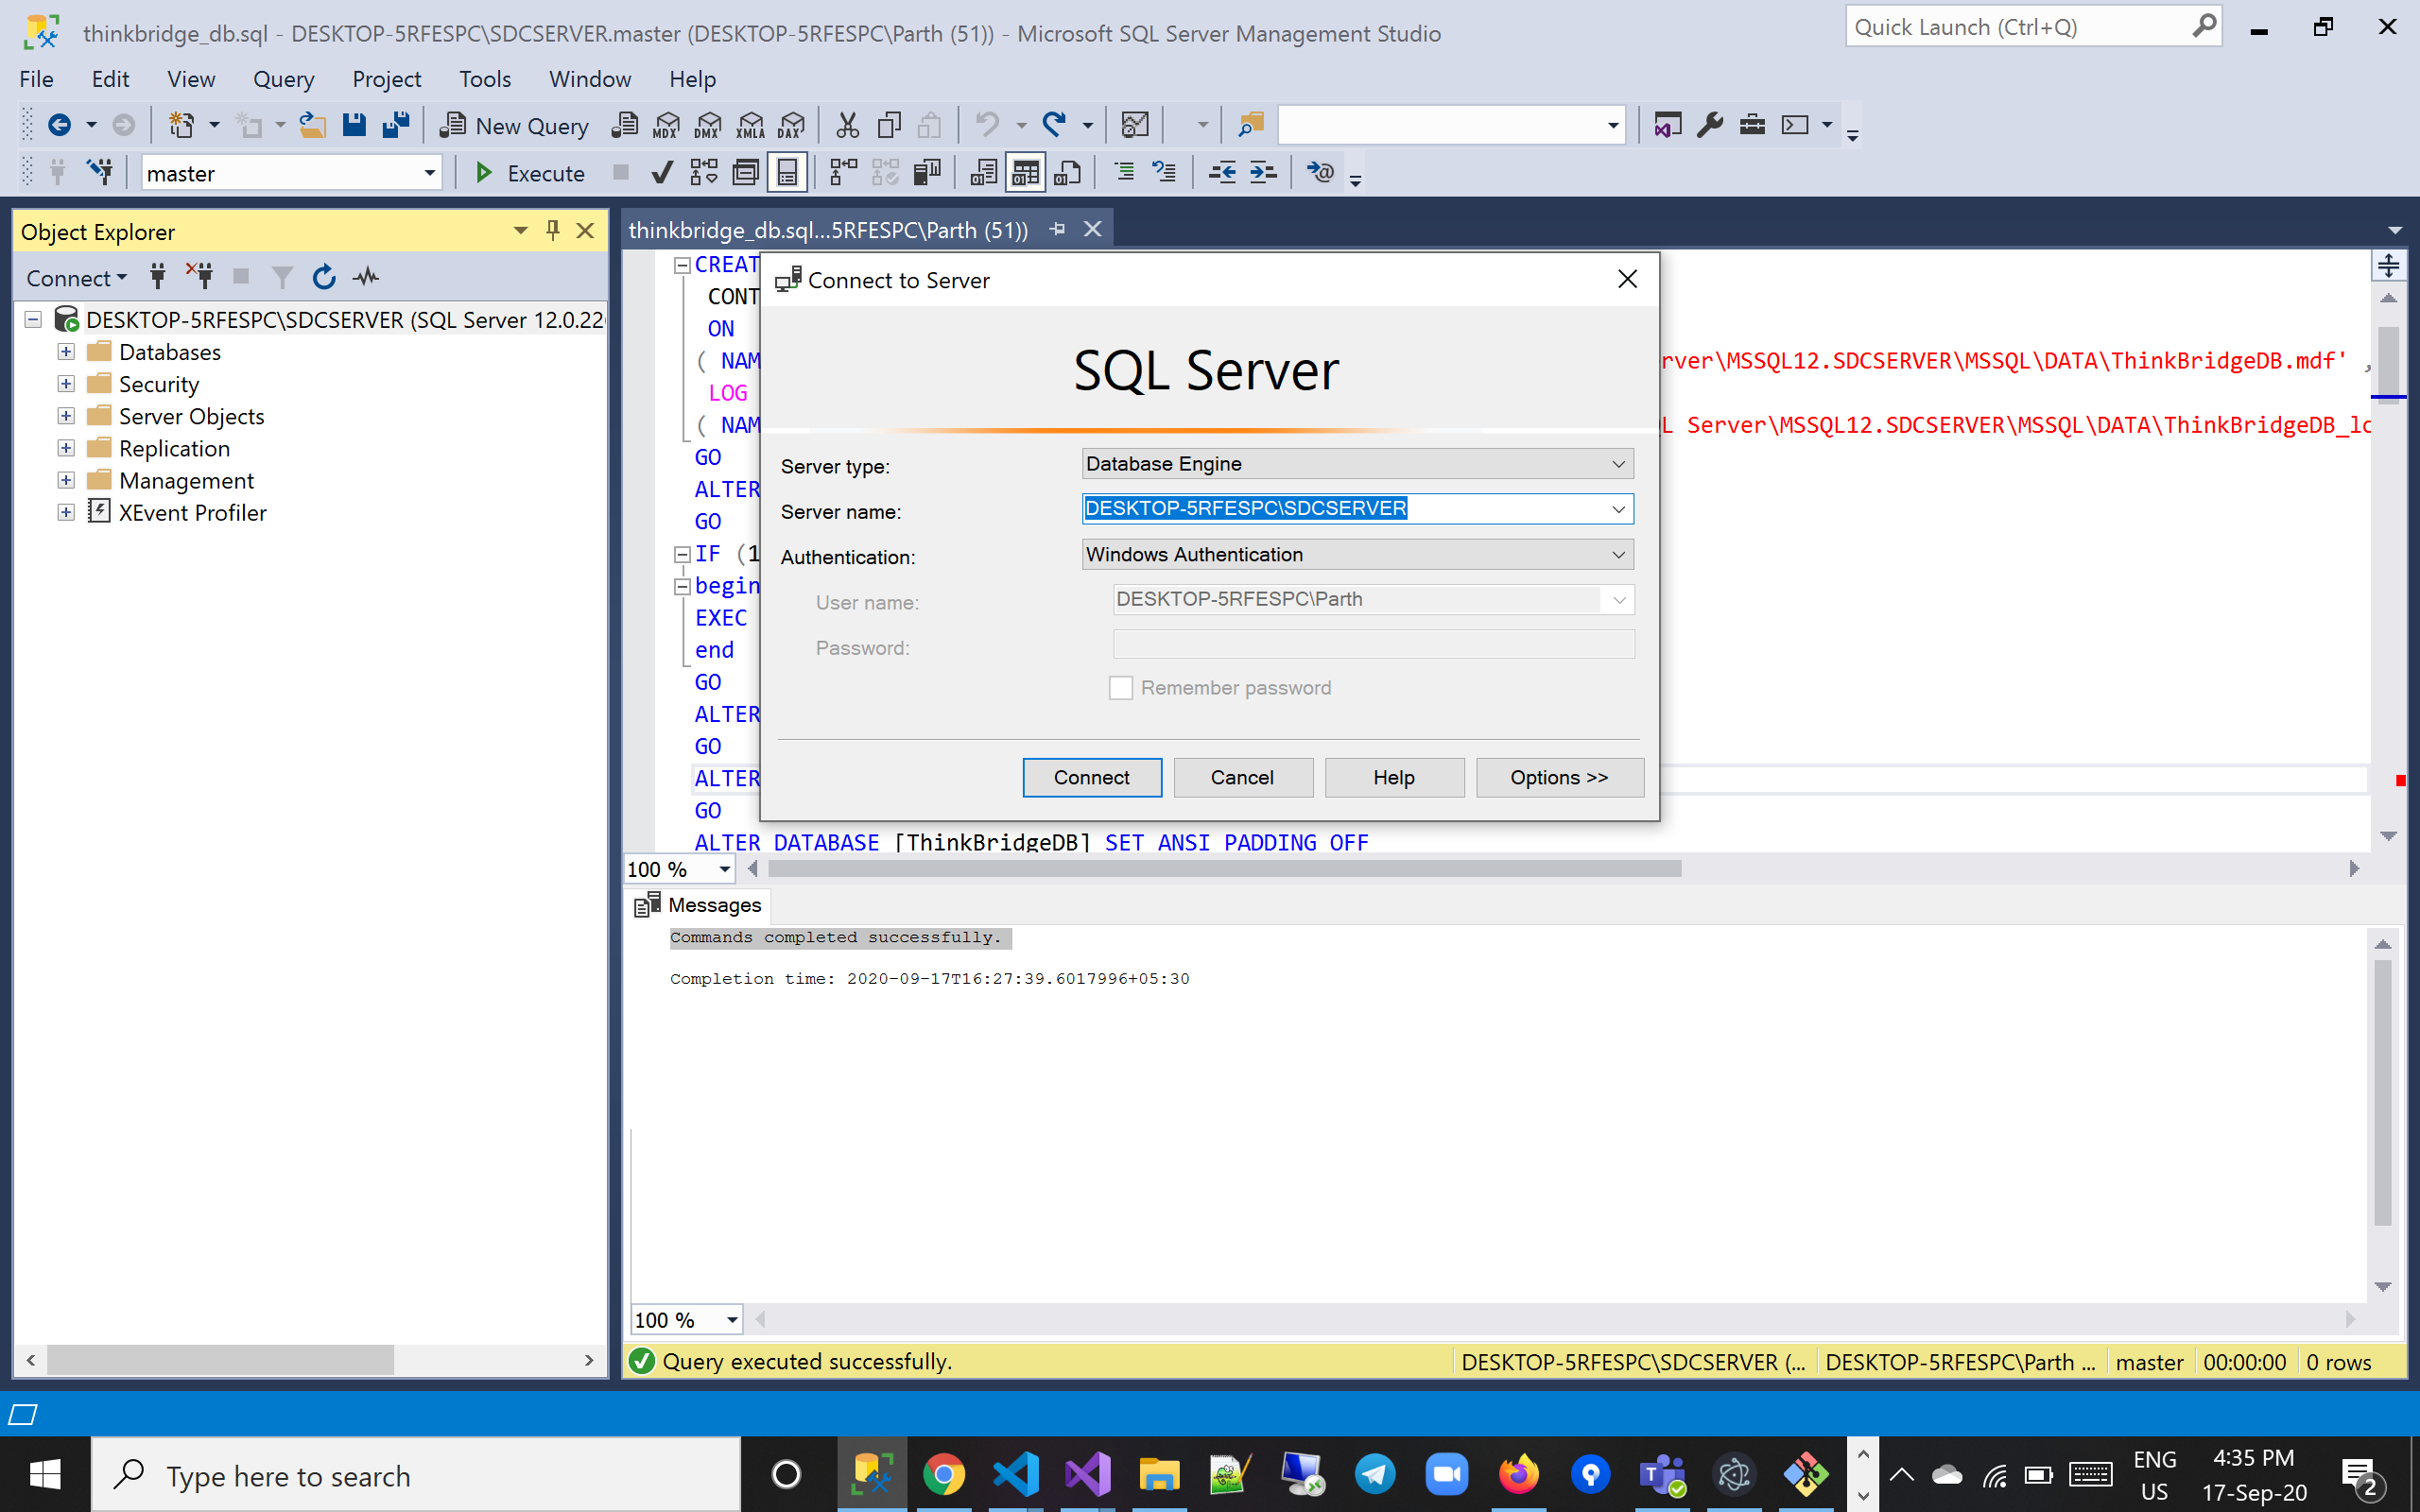

* I have kept windows authentications as it is a sample project to demonstrate the skills so no user name password needed but if u have sql authentication the change connection string accordingly
* Once done with this run the api project in VS
* I have set the lauch url in launch setting.json file to ‘http://localhost:52140’ but due to any reason VS changes it in clone then please copy the same url and paste it in frontend project -> environment.ts file

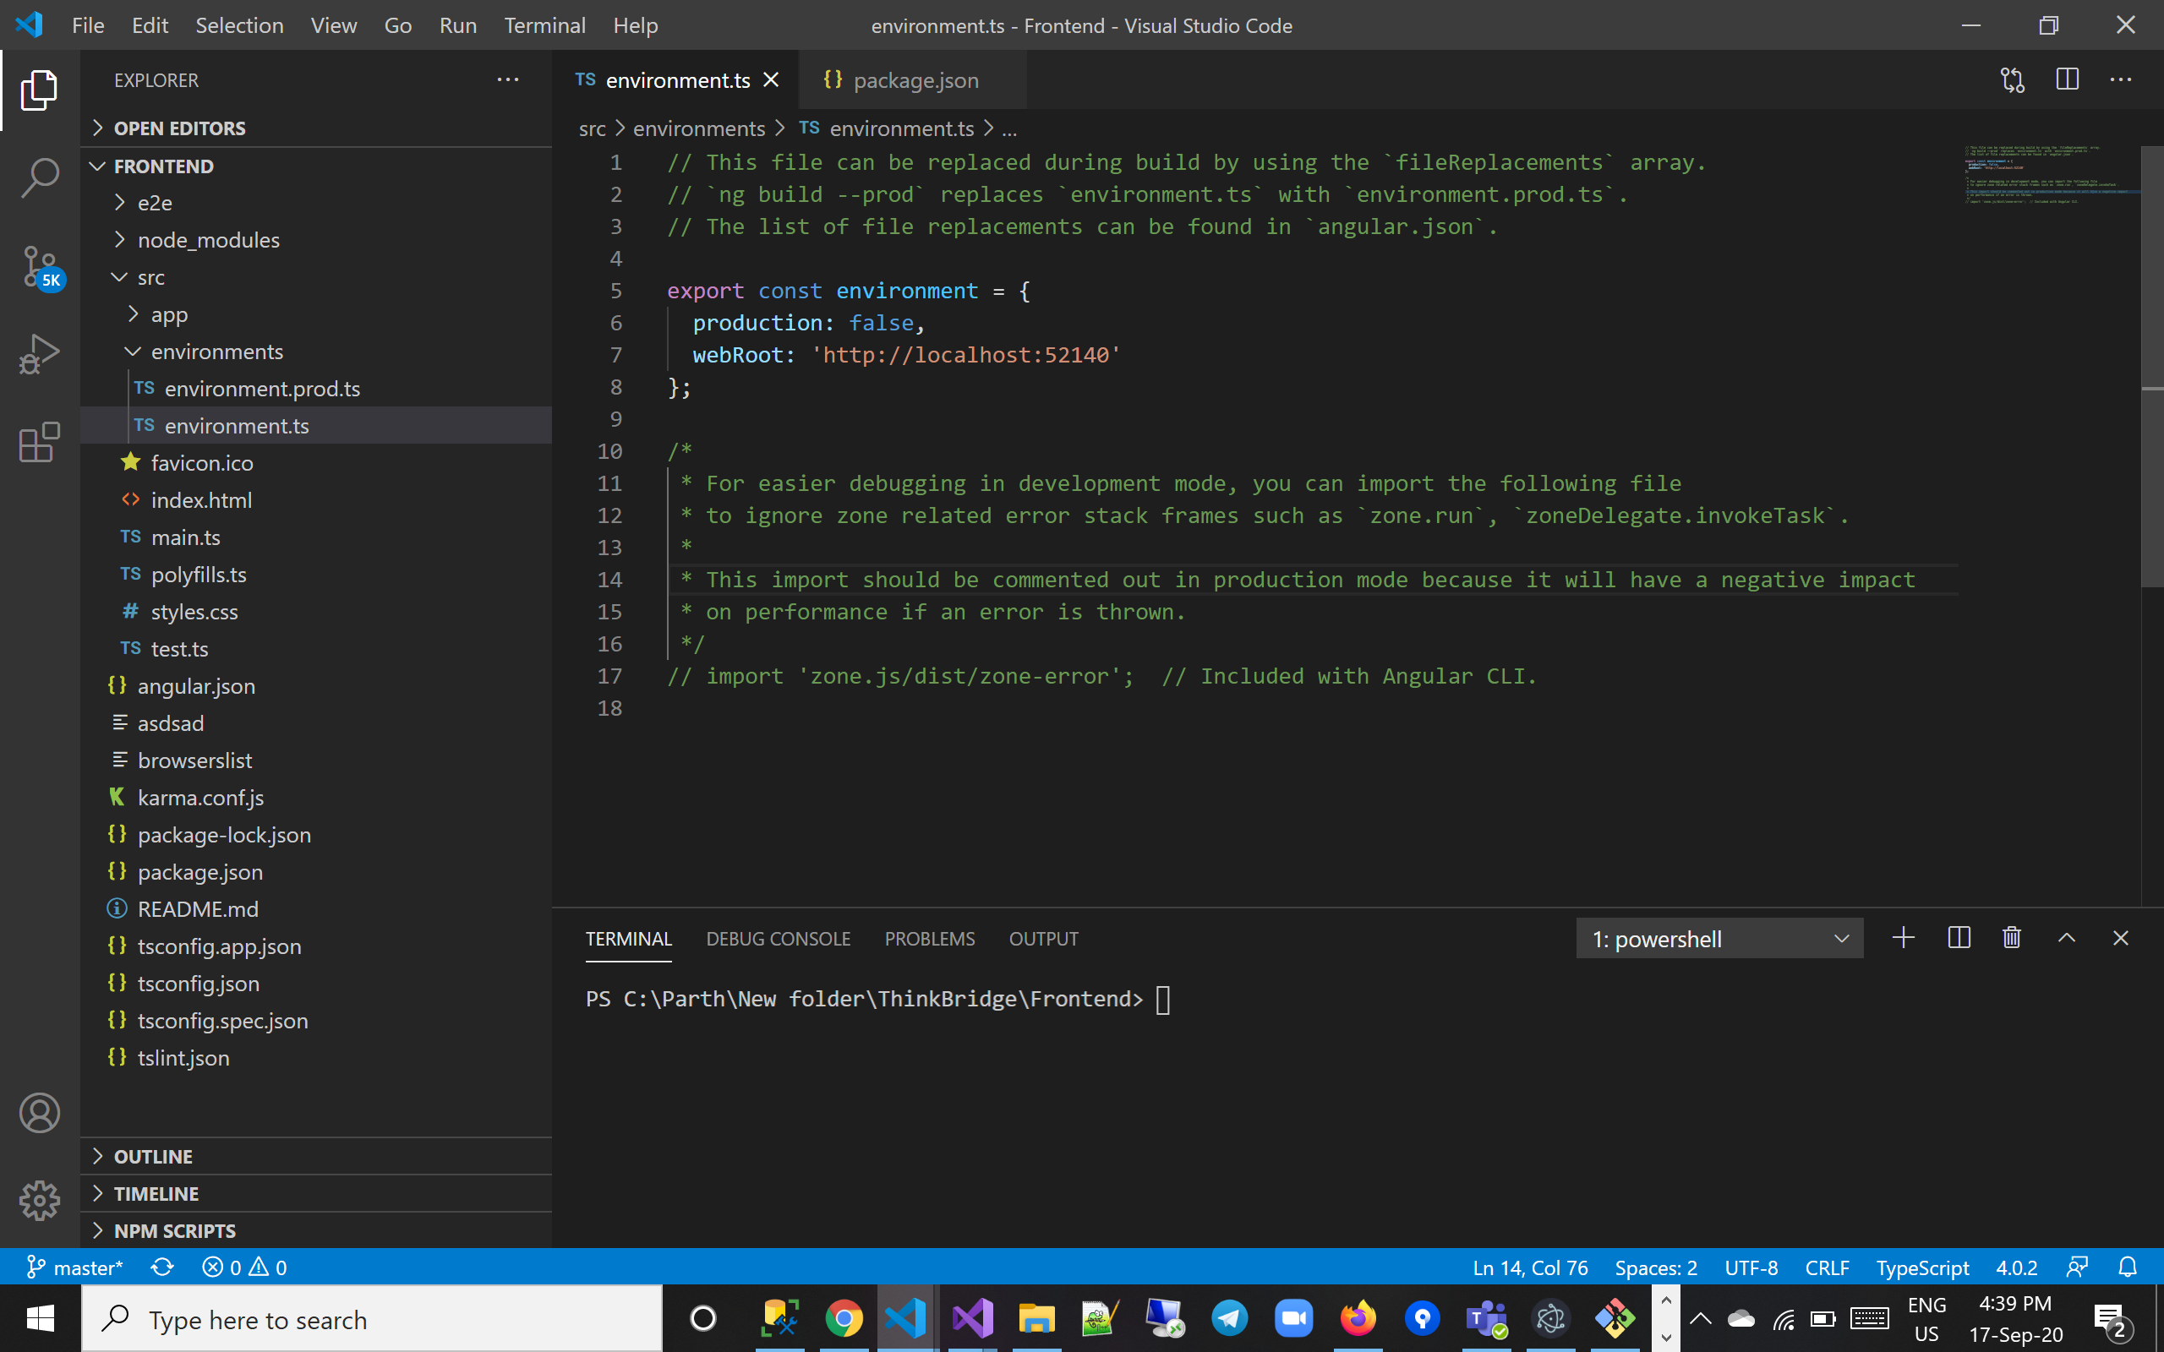

*6.Running the frontend*

-> Once the DB is created and connection string is set and backend api project and url is managed in environment.ts file Is running we are good to run the frontend as well

-> Not to forget we have applied ‘npm install’ command if not please run it

-> after npm install we are good to run the frontend as well

-> ‘npm start’ run command to run the project

*Time Tracking :*

* Backend Functionality : 2 hrs (includes sql DB)
* Frontend Functionality : 3 hrs
* Backend – Frontend Integration : 1 hrs
* Unit Test Converage : 2 hrs

*Why I choose particular Technologies to implement the deliverables?*

* Being a Backend guy I have be practicing Microsoft technologies from my college days and being experienced in same for almost 4 years I was confident to use .net core and sql DB for this implementations
* I have Experience of 2 year + in angular technologies and its is one of the hottest tech for frontend
* I have kept sample simple as the requirements where to keep it simple

*What all I have could have implemented but dint ?*

* As the requirements dint mention any specific so I dint use most of the technologies I have been practicing like EF core code first approach
* Some of the hottest frame works in .net core i.e aspnetboiler plate and abp.io currently working these tech as they are the hottest in the market
* Dint implement any security on the application as it was mentioned to keep it simple and also would have taken more time